Marlings Park Branch
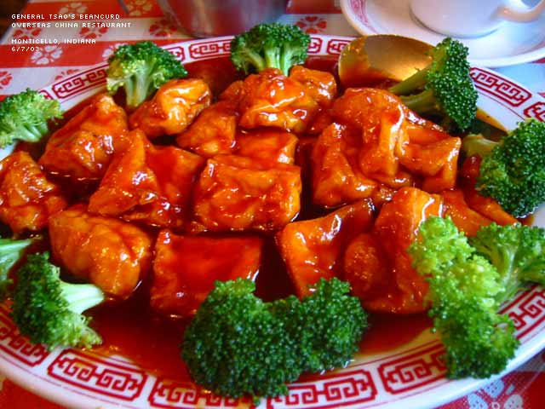
Conservatives
Invite you
to a

CHINESE EVENING
on
Tuesday 26th February 2019
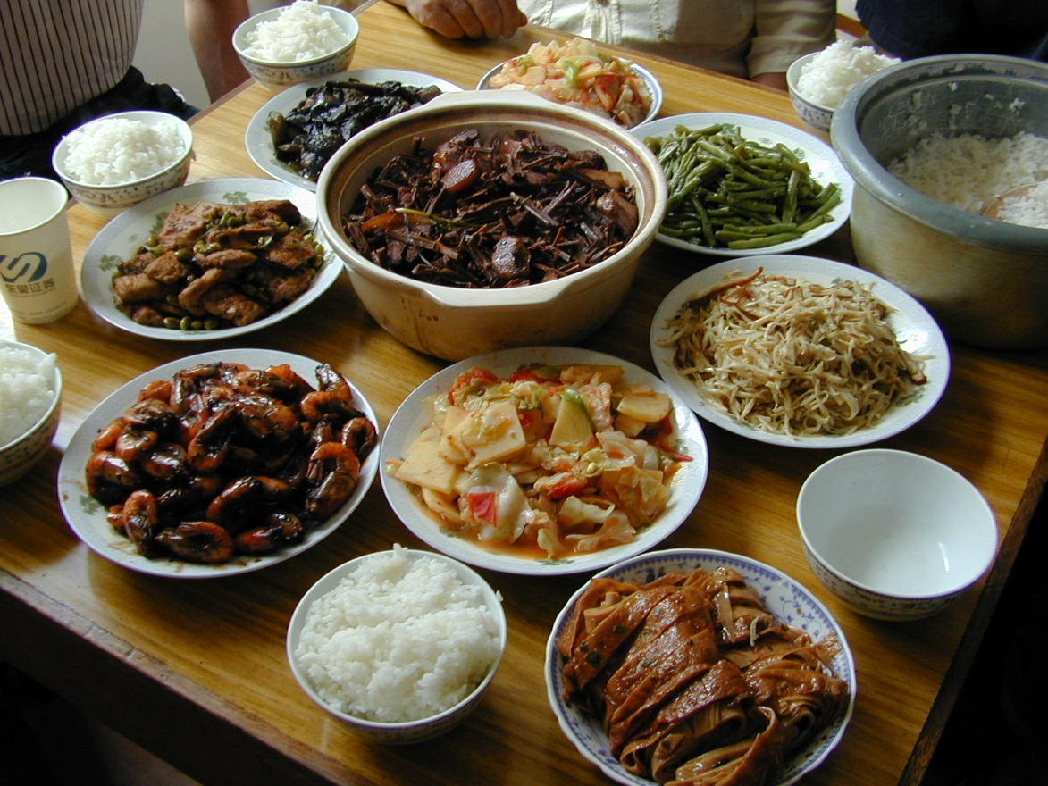
7.00pm for 7.30pm

Ming’s Chinese Restaurant
23 Station Square
Petts Wood, BR5 1LY

MENU
One Free Welcome Drink
Hot Hors D’Oeuvres
Satay Chicken, Spring Rolls, Spare Ribs, Crispy Seaweed
Sesame Prawn on Toast, Crispy Won Ton
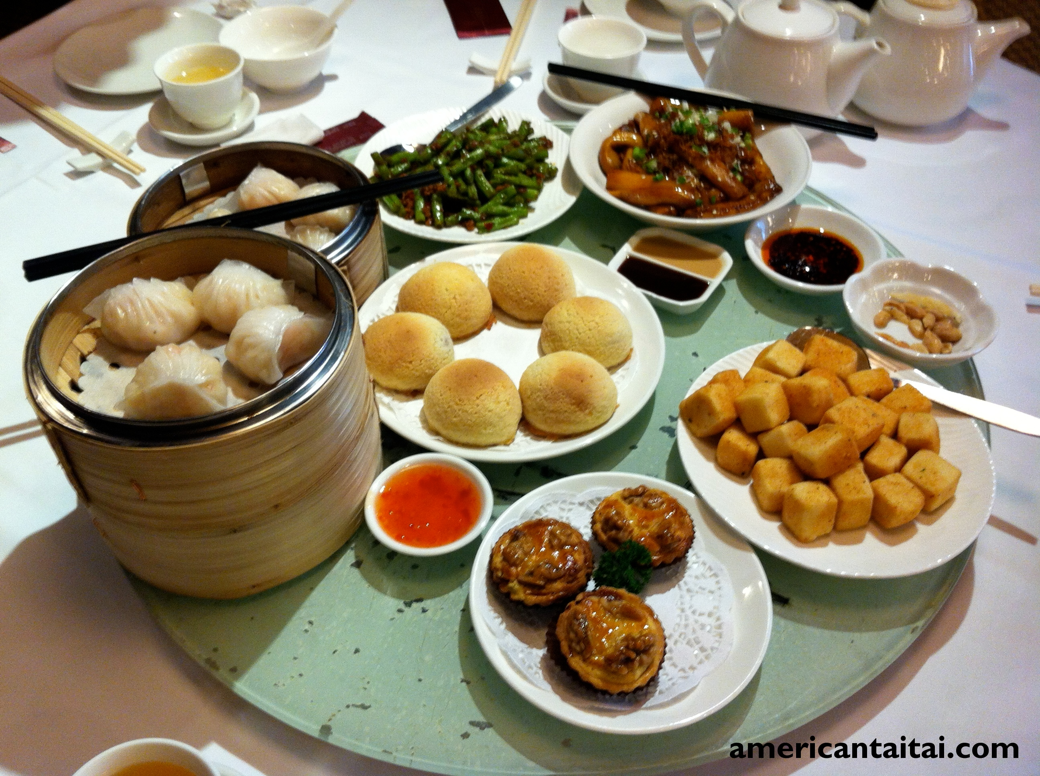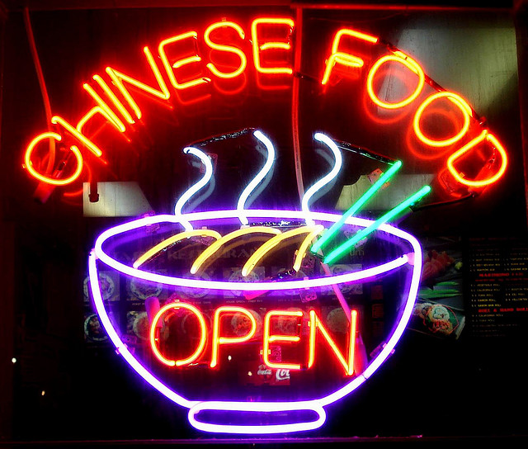
Crispy Aromatic Duck
Sizzling Prawn with Ginger and Spring Onions
Sweet and Sour Chicken Hong Kong Style
Bee Beef with Green Peppers in Black Bean Sauce
Stir Fried Mixed Vegetables
Special Fried Rice

Raffle Tickets will be on sale on the night, and any prizes would be gratefully received!
_________________________________________________________________________________________

ORDER FORM
I would like to book ………….... places @ £23.50 each for the Chinese Evening at Ming’s Restaurant, Station Square, Petts Wood on 26th February 2019.
I enclose a cheque for £…….……. made payable to BCCA
Name:_________________________________________________
Phone: ____________________ Email: _________________________________________________
Please return this Form with cheques to Terry Bosshard, 53 Marlings Park Avenue, Chislehurst BR76RD. Alternatively, you may wish to make your payment via online bank transfer to account no. 40182850, sort code 20-14-33, Barclays Bank, in the name of Dr & Mrs Bosshard, and please add your name as reference. No tickets will be issued. Please send your requests in early, as this is a popular evening.
There is plenty of parking space in Petts Wood Station Square, and Station car parks close to Ming’s Restaurant.

